**Assignment – 9 - SSIS**

Dataset: You can use **sales_data_sample.csv** or you are also open to generate new dataset using **mockaroo.com** (if required).

**Submit the following in a single zip file:**

1. All SSIS package files for each task named as per task names.
2. Documentation with screenshots and explanations for each step of the tasks.
3. Any additional scripts or configuration files used in the tasks.

**Task 1: Integration with ETL Data Warehouse (DWH)**

Scenario: Your company has a data warehouse designed to consolidate data from various sources for analytical purposes. You need to create an SSIS package that extracts data from a transactional database and loads it into the data warehouse.

**Requirements:**

Create a Connection Manager to connect to the transactional database and the data warehouse.

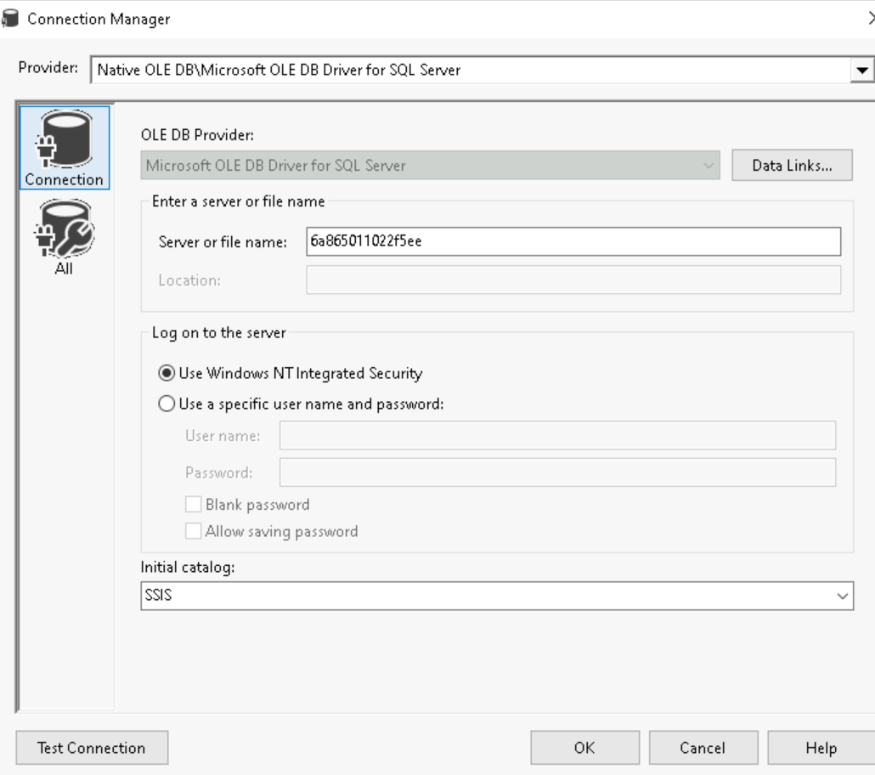

Extract Data from a transactional table (e.g., SalesData) using an OLE DB Source.

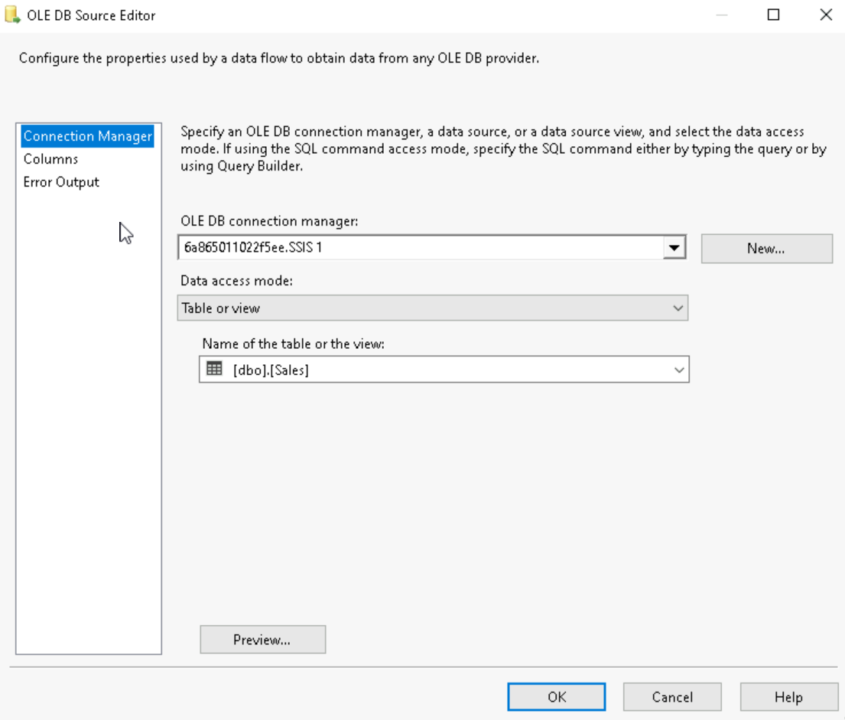

Transform Data:  
Apply necessary transformations such as data type conversions, data cleansing, and calculations.

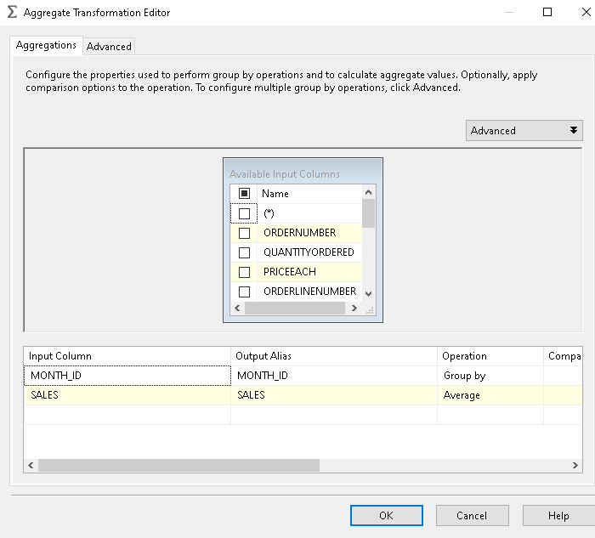

Load Data into the data warehouse.

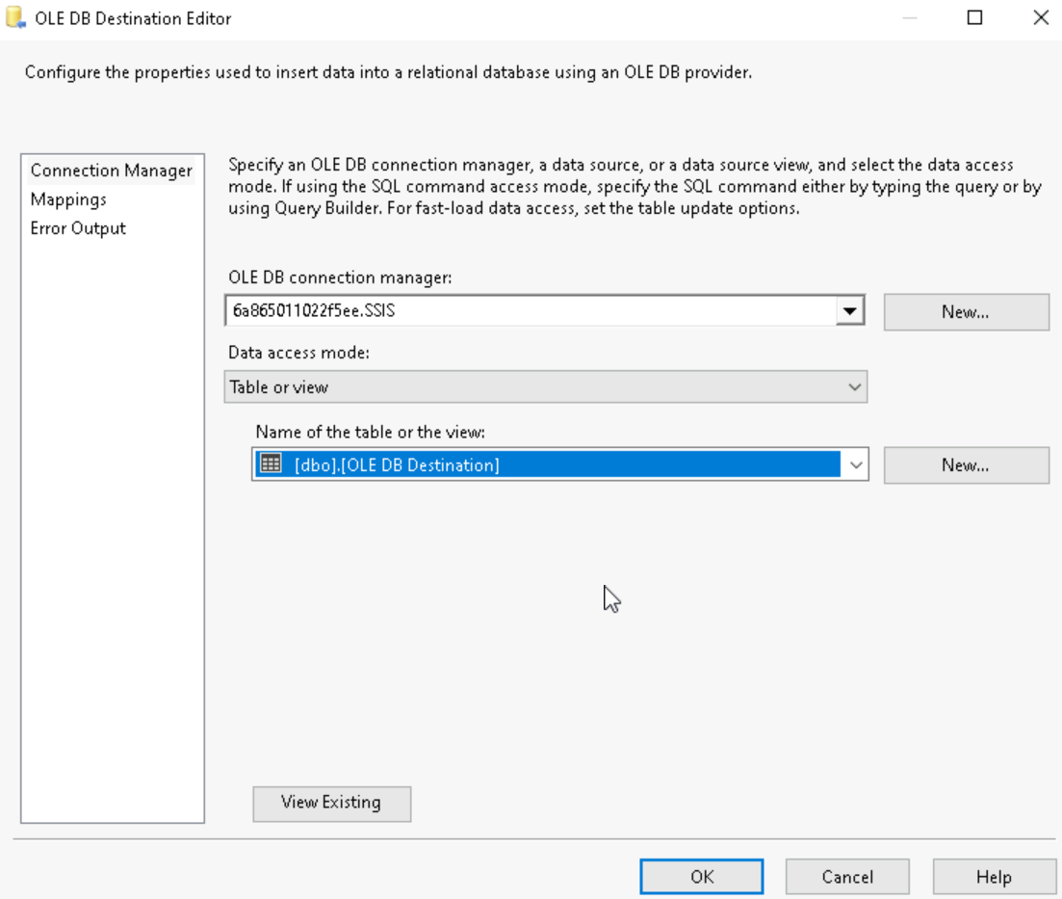

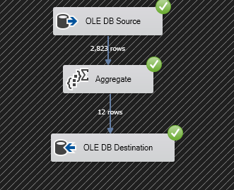

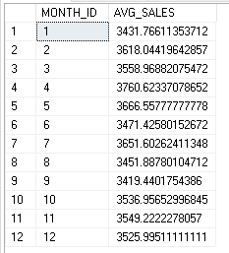

**Task 2: Data Warehouse Migrations**

Scenario: Your organization is migrating its data warehouse from one server to another. You need to create an SSIS package that facilitates this migration.

Requirements:

1. Create Connection Managers for both the source and destination data warehouses.
2. Transfer Data from the source data warehouse to the destination using the Data Flow Task.
3. Ensure Data Integrity:
   1. Include checks and balances to ensure data is correctly migrated.
   2. Log the success or failure of the migration process.









**Task 3: Implementing a Pivot Transformation**

Scenario: You have data in a normalized format and need to pivot it for reporting purposes.

Requirements:

1. Extract Data from the source table using an OLE DB Source.
2. Apply a Pivot Transformation to transform the normalized data into a pivoted format.

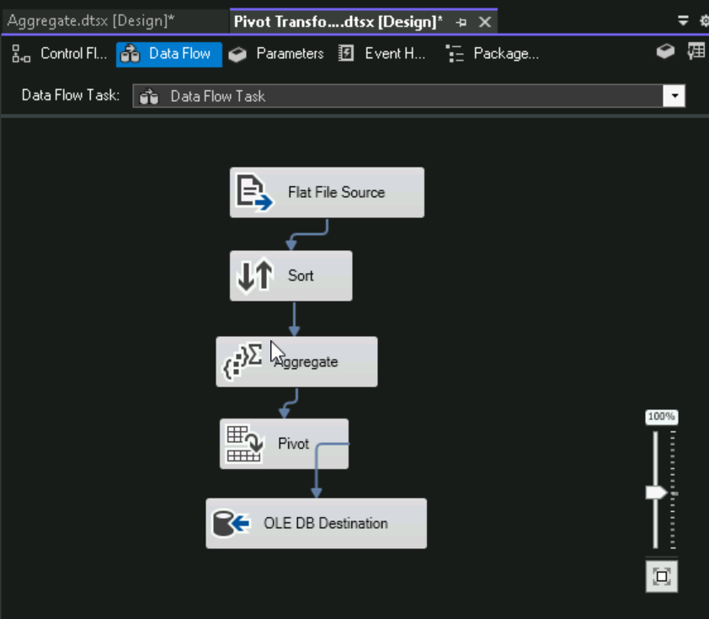

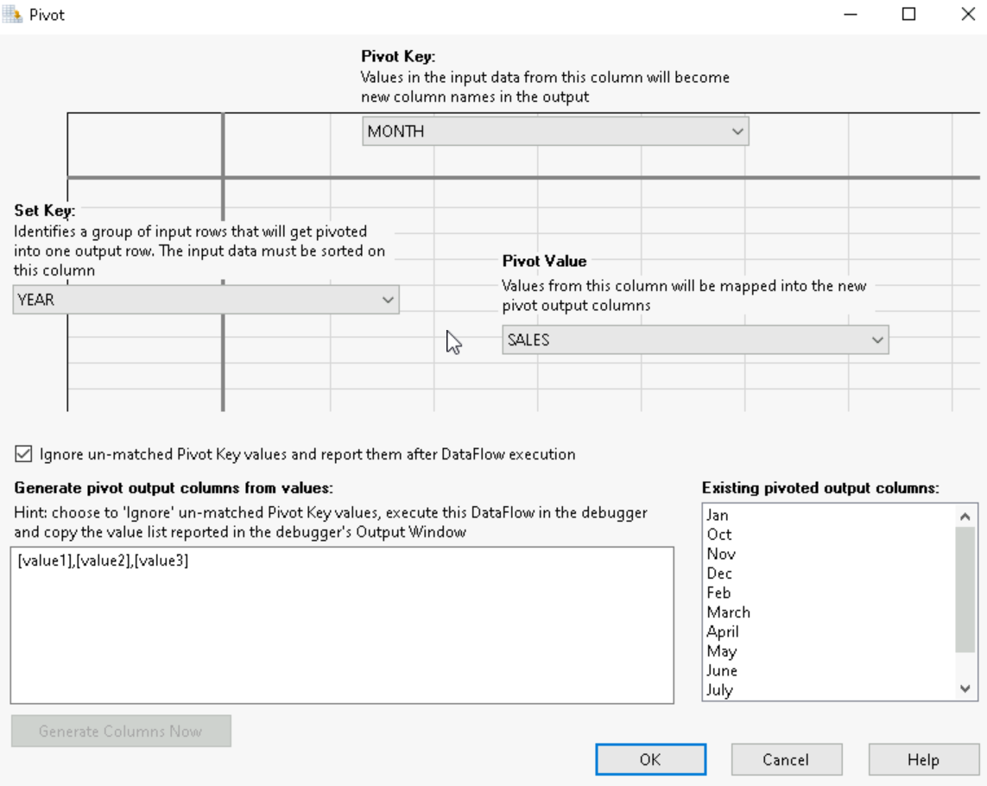

1. Load the Pivoted Data into a destination table.

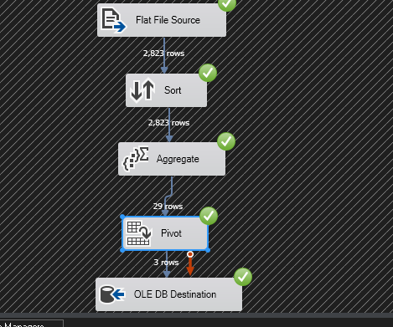

**Task 4: Incremental Load**

Scenario: To optimize ETL processes, you need to implement an incremental load to update only the changed data in the data warehouse.

Requirements:

1. Identify Changed Data: Use methods such as timestamps, change data capture using lookup, or checksums.
2. Extract Only the Changed Data from the source.
3. Update the Data Warehouse with the new and changed data only.

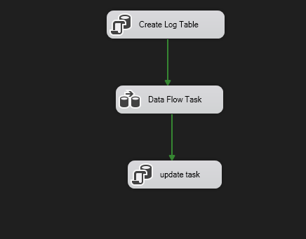

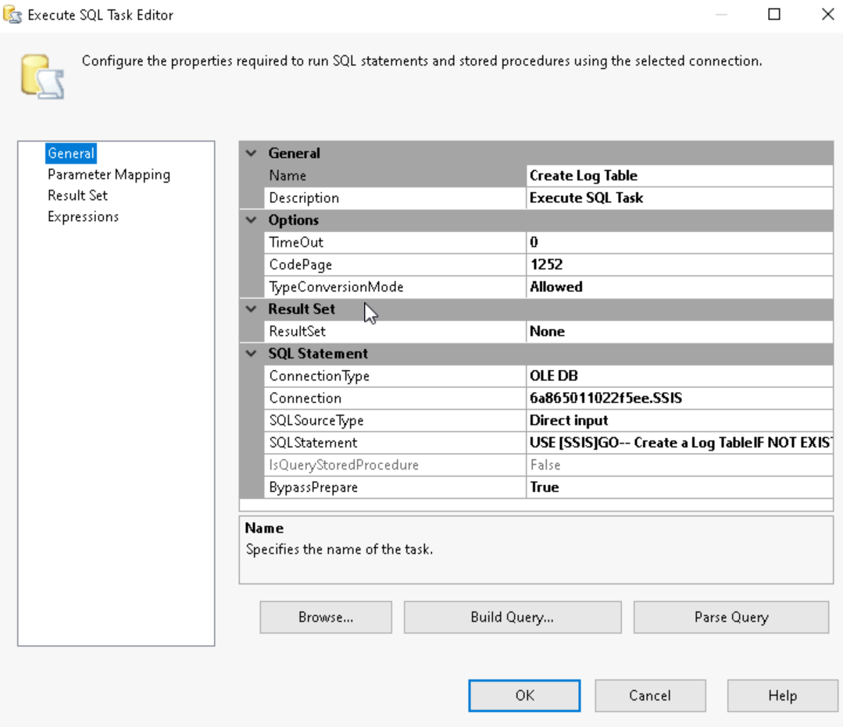

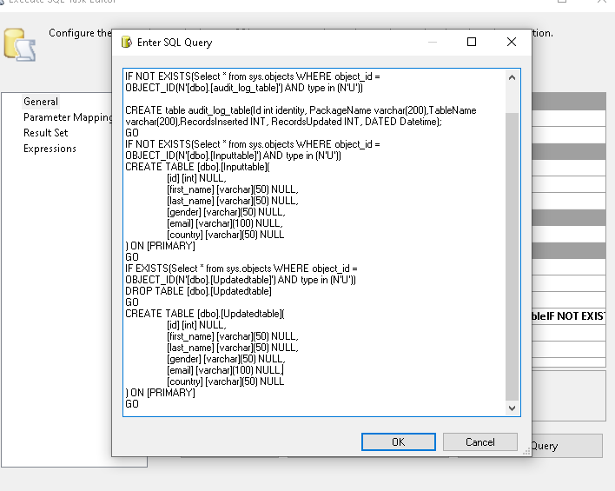

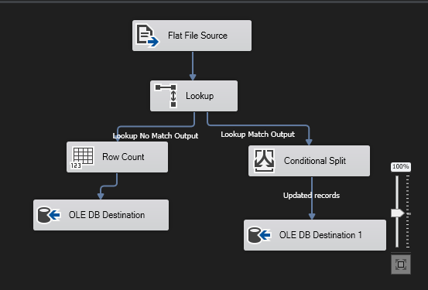



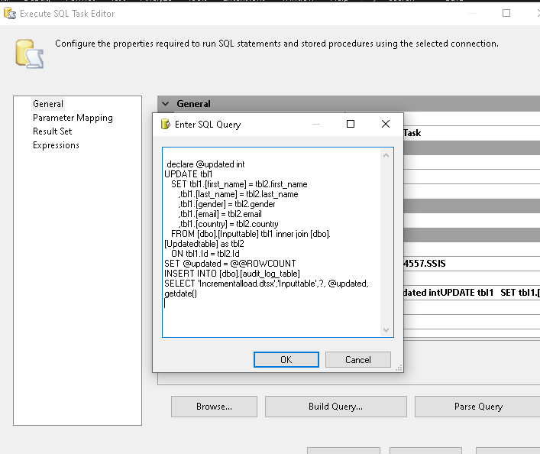

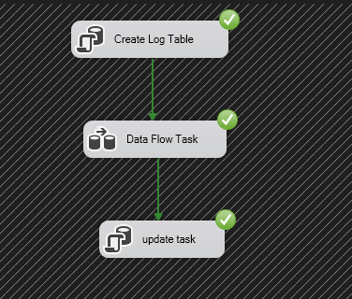

**Task 5: Transformations**

Scenario: Your company needs to transform raw data into a format suitable for reporting. You need to perform multiple transformations within an SSIS package.

Requirements:

1. Extract Data from a source table using an OLE DB Source.
2. Apply Transformations such as:

* Data Conversion
* Derived Column
* Conditional Split
* Aggregate

1. Load Transformed Data into a destination table.

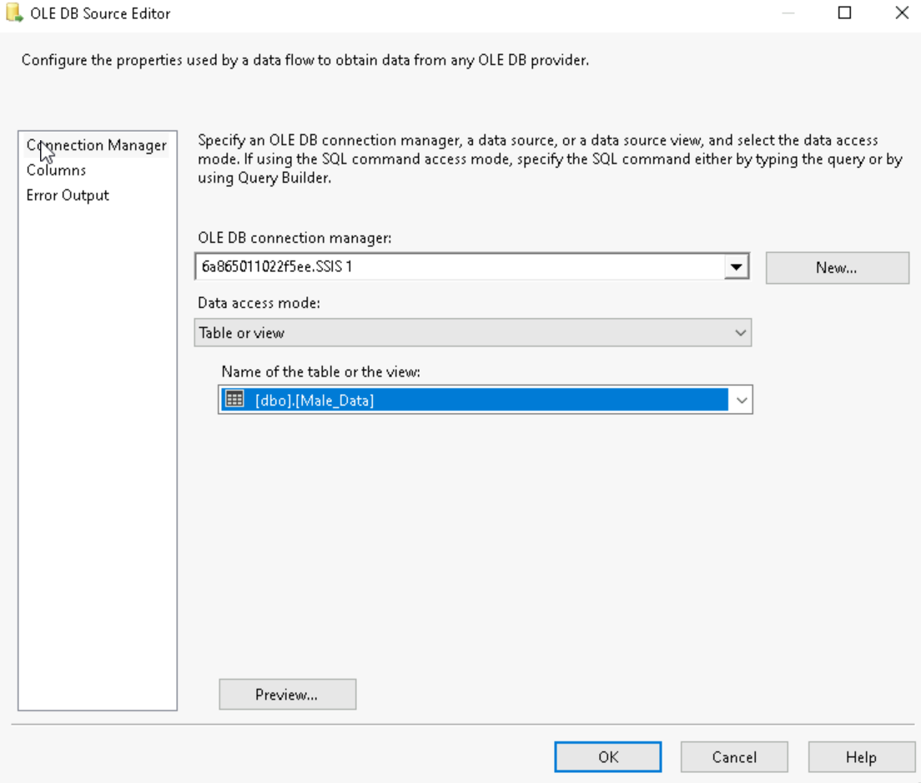

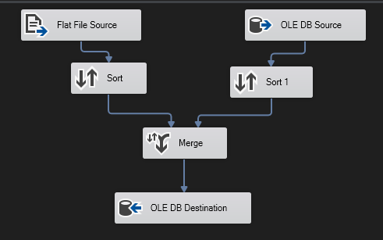

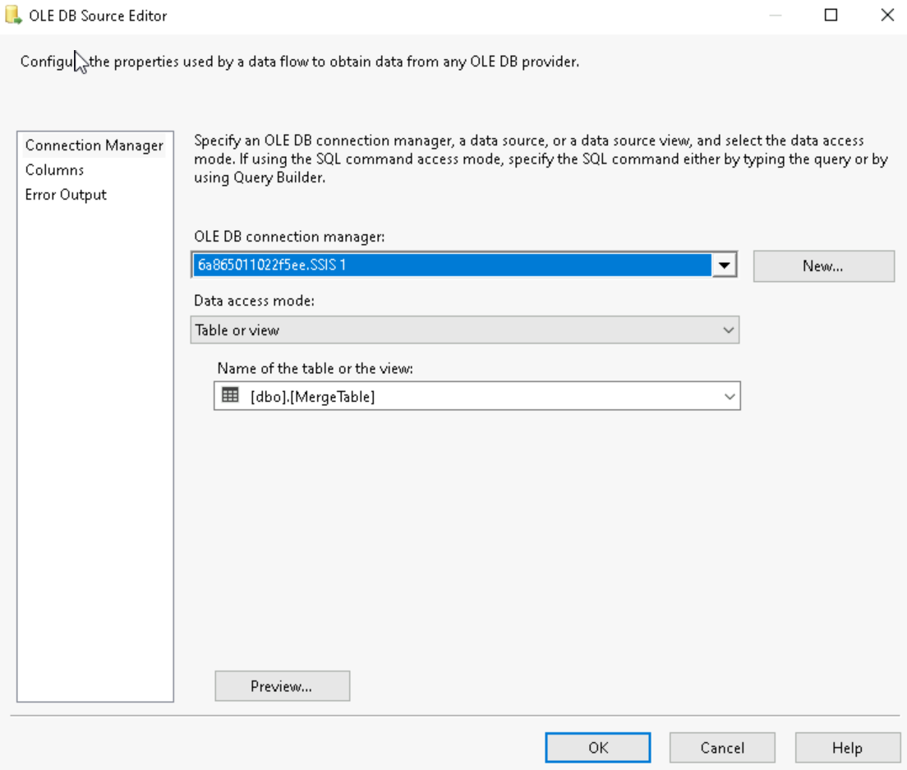

**Task 6: MERGE & FUZZY LOOKUP**Scenario: You need to merge two datasets and use fuzzy matching to handle potential duplicates.

Requirements:

1. Extract Data from two source tables using OLE DB Sources.
2. Apply a Merge Join to combine the datasets based on a common key.
3. Use Fuzzy Lookup to identify and resolve duplicates in the merged data.
4. Load the Cleaned Data into a destination table.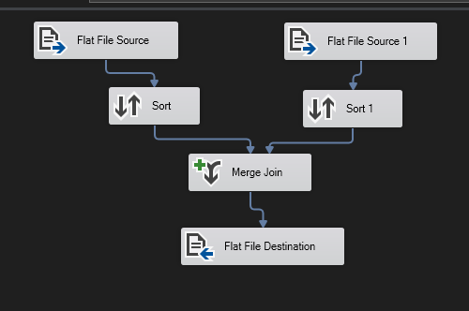

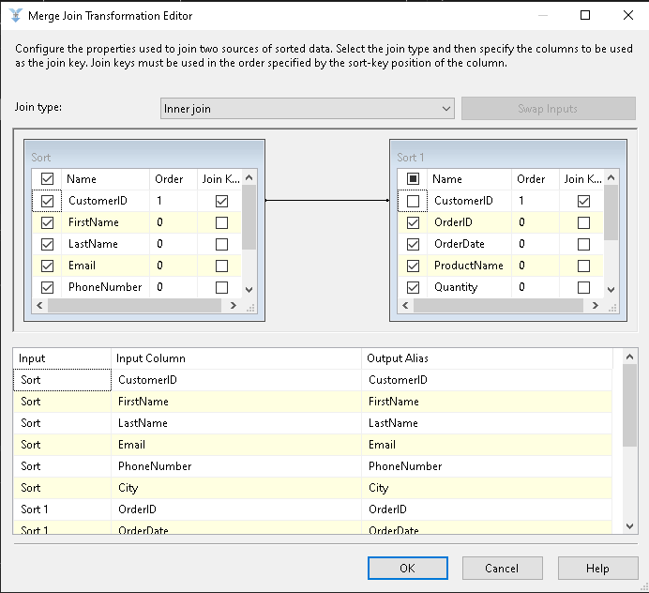

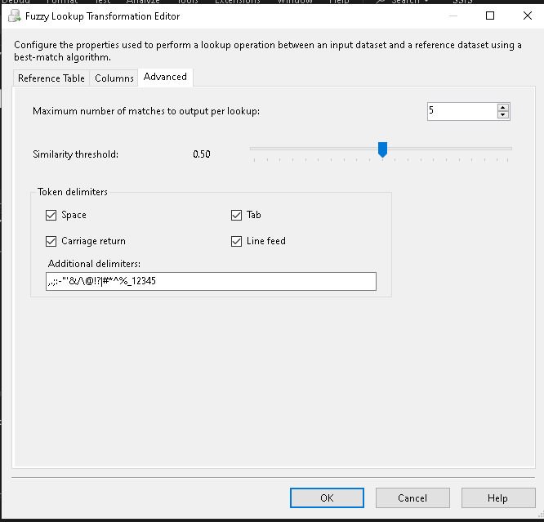

**Task 7: Using Script Task**

**Scenario:** You need to perform a complex data transformation that is not supported by the standard SSIS components. A Script Task can be used to achieve this.

Requirements:

1. Add a Script Task to the Control Flow.
2. Write a Script: that performs the required transformation. e.g. Reading data from a file, processing it, and writing the results to a database table.
3. Execute the Script Task within an SSIS package.











